Pokhara University

Level: Bachelor | Semester – Fall | Year : 2011
Programme: BE |  | Full Marks: 100
Course: Engineering Mathematics IV |  | Pass Marks: 45
 |  | Time : 3hrs.

Candidates are required to give their answers in their own words as far as practicable.
The figures in the margin indicate full marks.

Attempt all the questions.

 | - State and prove the necessary condition for a function f(z) = u + iv to be analytic.  - Evaluate the following integrals using Cauchy's integral formula  ∫  dz,  C : ⎪z-2⎪ = 3/2  z +1  z³-4z  i)  c  O  ∫  z +1  z³-2z²  O  dz, C is the unit circle.  ii)  c | 8  7
 | - State Laurent's series. Expand the function f(z) = 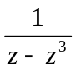 in the region 1</z-1/<2  OR  State Cauchy's residue theorem. Use it to evaluate the integral 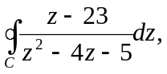 where C: /z-2/ = 4  - Find the solution of one dimensional wave equation corresponding to the triangular initial deflection.  f (x) = 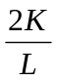x, if 0< x < L/2  = ( L- x ), if L/2 < x < L  with its initial velocity zero and c = 1 | 7  8
 | - Find u (x, t) from one one dimensional wave equation 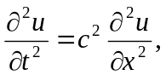with boundary condition. 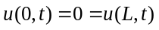, initial deflection 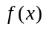and initial velocity 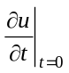= g(x).  - Derive one dimensional heat equation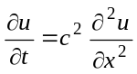with necessary assumptions. | 8  7
 | - Define Z – transform? Find the inverse of the Z- transform of the function,  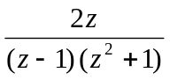  - Define Fourier integral. Find the Fourier cosine and sine integrals of the function 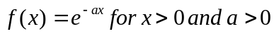 | 8  7
 | - Using Z-transform, solve the difference equation  - Maximize z = 20x₁ + 20x₂ subject to –x₁ + x₂ ≤ 1, x₁+3x₂ ≤ 15, 3x₁+x₂ ≤ 21, x₁ ≥ 0, x₂ ≥ 0 | 7  8
 | - Find the Z- transform of the function f(t) = 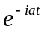 and hence deduce the value of Z(cosat) and Z(sinat).  - Derive an expression for the Fourier integral from a Fourier series  - Find the Fourier cosine and sine transform of 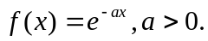 | 5  5  5
 | Answer the following questions:  - Represent the equation 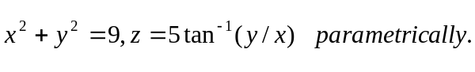  - Find the unit tangent vector to the curve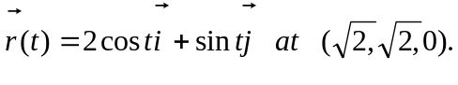  - Sketch the feasible region of the inequalities  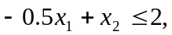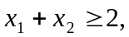  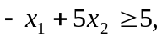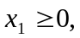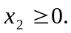  - Show that where F_{c} is the Fourier cosine transform. | 2.5  2.5  2.5  2.5

